Project

IoT Home Automation System

MCA Semester - 2

* Aakanxa Modha (230970031)

Contents

1. Title Page
2. Abstract
3. Project Introduction
4. Components used in the Project
5. Pin Tables
6. Diagrams
7. Arduino Code
8. Bibliography

I.

Title Page

Title: IoT Home Automation System

Name: Aakanxa Modha

Registration number: 230970031

Roll No.: 25

Class: MCA 2A

Course: Internet of Things (IoT)

II.

Abstract

The IoT Home Automation System project aims to utilize the TinkerCad platform, integrating various sensors and actuators. The objective is to transform a conventional house into a fully integrated IoT-enabled dwelling by automating various components. This IoT House project entails incorporating smart sensors, actuators, and connectivity solutions to streamline and enhance everyday tasks and functionalities within the household. By leveraging IoT technology, residents can remotely monitor, control, and optimize diverse aspects of their home environment, including lighting, fans, security systems, and appliances. By harnessing the capabilities of IoT, residents can experience heightened convenience and efficiency in managing their home's functionalities from anywhere with an internet connection.

III.

Project Introduction

The IoT Home Automation System is a groundbreaking project that aims to transform conventional household management through the integration of IoT technology. By automating various aspects of home functionality, such as lighting, temperature control, security systems, and appliance management, this project promises to revolutionize daily living.

Implementing the IoT Home Automation System involves automating household appliances through a variety of sensors and actuators. When applied in real life, this project significantly enhances the daily lives of ordinary people and contributes to resource conservation by reducing wastage. Its user-friendly design ensures ease of use, making it accessible even to individuals with no prior knowledge of IoT technology. Overall, the IoT Home Automation System not only simplifies tasks but also promotes sustainability and efficiency in everyday living.

In this project, TinkerCad serves as the cornerstone platform, facilitating the integration of sensors, actuators, and Arduino programming. Through this combination, the IoT Home Automation System achieves advanced functionalities, extending its capabilities beyond conventional automation.

IV.

Components used in Project

Sensors

1. Ultrasonic Distance Sensor
2. Photoresistor
3. PIR Sensor
4. Gas Sensor

Actuators

1. DC Motor
2. Positional Micro Servo
3. Relay SPDT (x2)
4. Piezo
5. Light Bulb (x2)

Other Components

1. Arduino Uno R3
2. Slideswitch
3. Power Supply
4. 5 kΩ Resistor
5. 1 kΩ Resistor

V.

Pin Tables

Arduino Uno R3

|  |  |
| --- | --- |
| 5V | Ultrasonic (5V) |
| GND | Ultrasonic (GND) |
| D6 | Ultrasonic (Singal) |
| D7 | Micro servo (Signal) |
| D8 | Piezo (Positive) |
| D9 | PIR sensor (Signal) |
| A0 | Photoresistor (Terminal 1) |
| A1 | Gas sensor (A2) |
| D10 | Relay 1 (Terminal 8) |
| D13 | Relay 2 (Terminal 5) |

Ultrasonic Distance Sensor

|  |  |
| --- | --- |
| 5V | Resistor 1 KΩ (Terminal 1) |
| 5V | Micro servo (Power) |
| 5V | PIR sensor (Power) |
| GND | PIR sensor (Ground) |
| GND | Micro servo (Ground) |
| GND | Photoresistor (Terminal 2) |

Micro Servo

|  |  |
| --- | --- |
| Ground | Piezo (Negative) |
| Ground | Relay 2 (Terminal 8) |
| Power | Gas sensor (B1) |

PIR Sensor

|  |  |
| --- | --- |
| Ground | Relay 1 (Terminal 5) |

Power Supply

|  |  |
| --- | --- |
| Positive | Slideswitch (Common) |
| Positive | Relay 1 (Terminal 6) |
| Negative | Bulb 1 (Terminal 1) |
| Negative | Relay 1 (Terminal 12) |

Gas Sensor

|  |  |
| --- | --- |
| H1 | Piezo (Negative) |
| B1 | Gas sensor (H2) |
| B2 | Gas sensor (H2) |

Resistor 5 KΩ

|  |  |
| --- | --- |
| Terminal 1 | Gas sensor (A1) |
| Terminal 2 | Gas sensor (H1) |

DC Motor

|  |  |
| --- | --- |
| Terminal 1 | Relay 1 (Terminal 6) |
| Terminal 2 | Slideswitch (Terminal 1) |

Relay 2

|  |  |
| --- | --- |
| Terminal 12 | Bulb 2 (Terminal 1) |

Bulb 1

|  |  |
| --- | --- |
| Terminal 2 | Bulb 2 (Terminal 2) |

Photoresistor

|  |  |
| --- | --- |
| Terminal 1 | Resistor 1 KΩ (Terminal 2) |

VI.

Diagrams

Circuit Diagram

1.

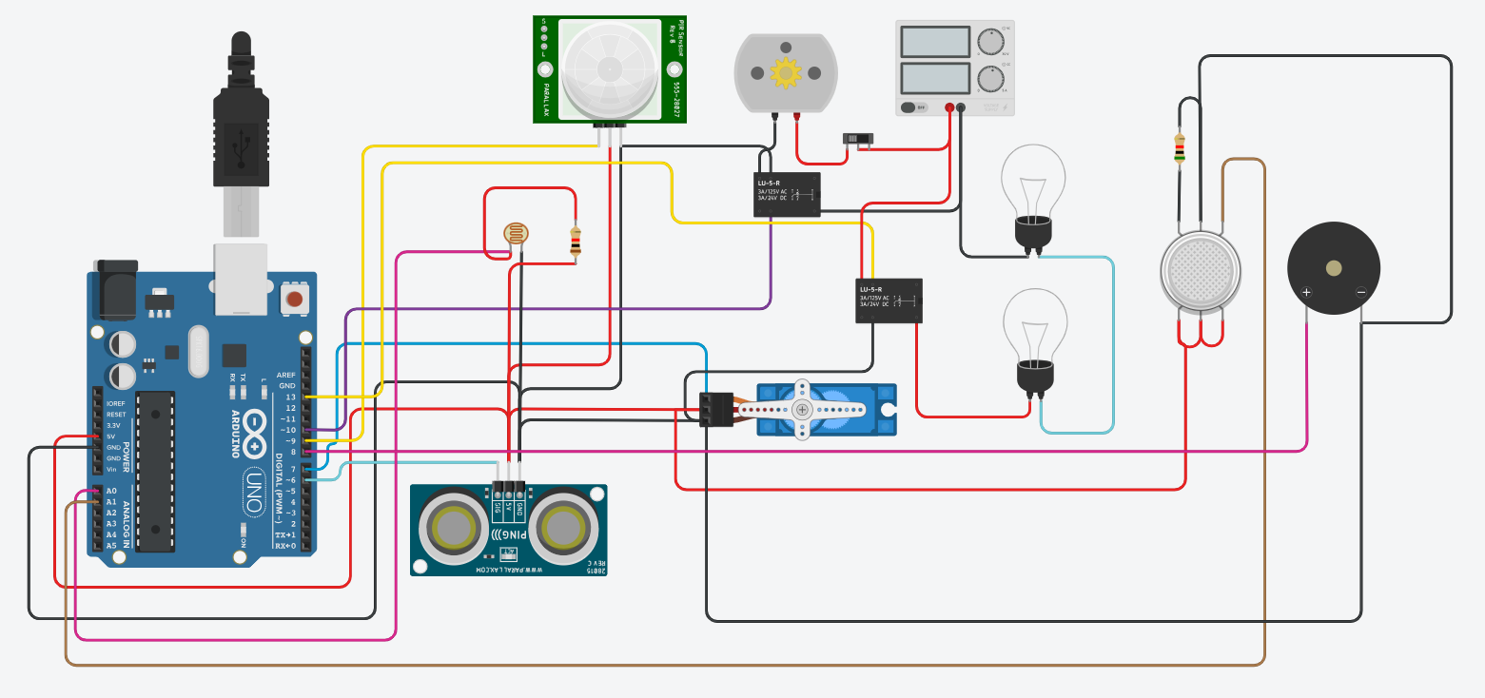

A complete circuit

2.

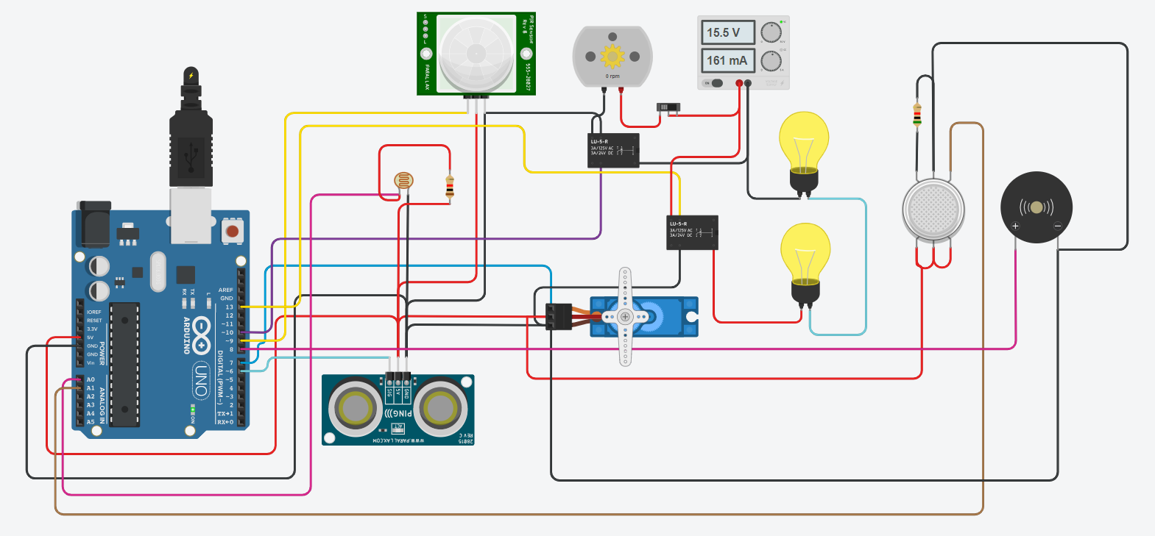

Gas is detected so, Piezo buzzes.

3.

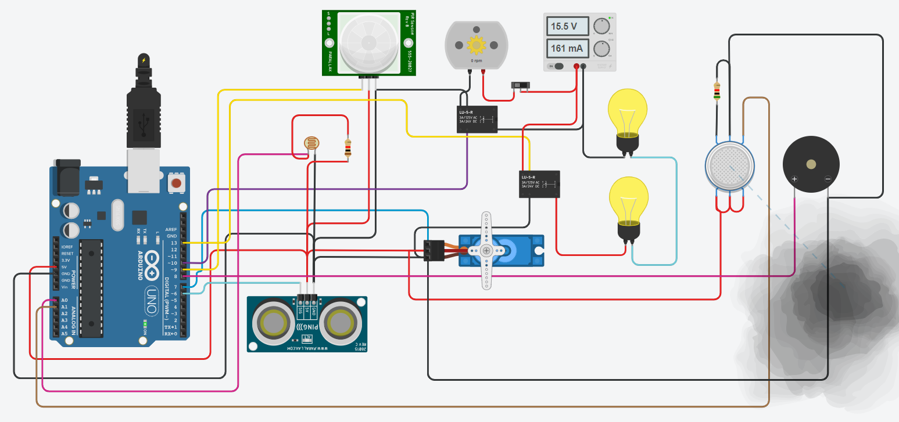

Gas is not there anymore so, Piezo stopped buzzing.

4.

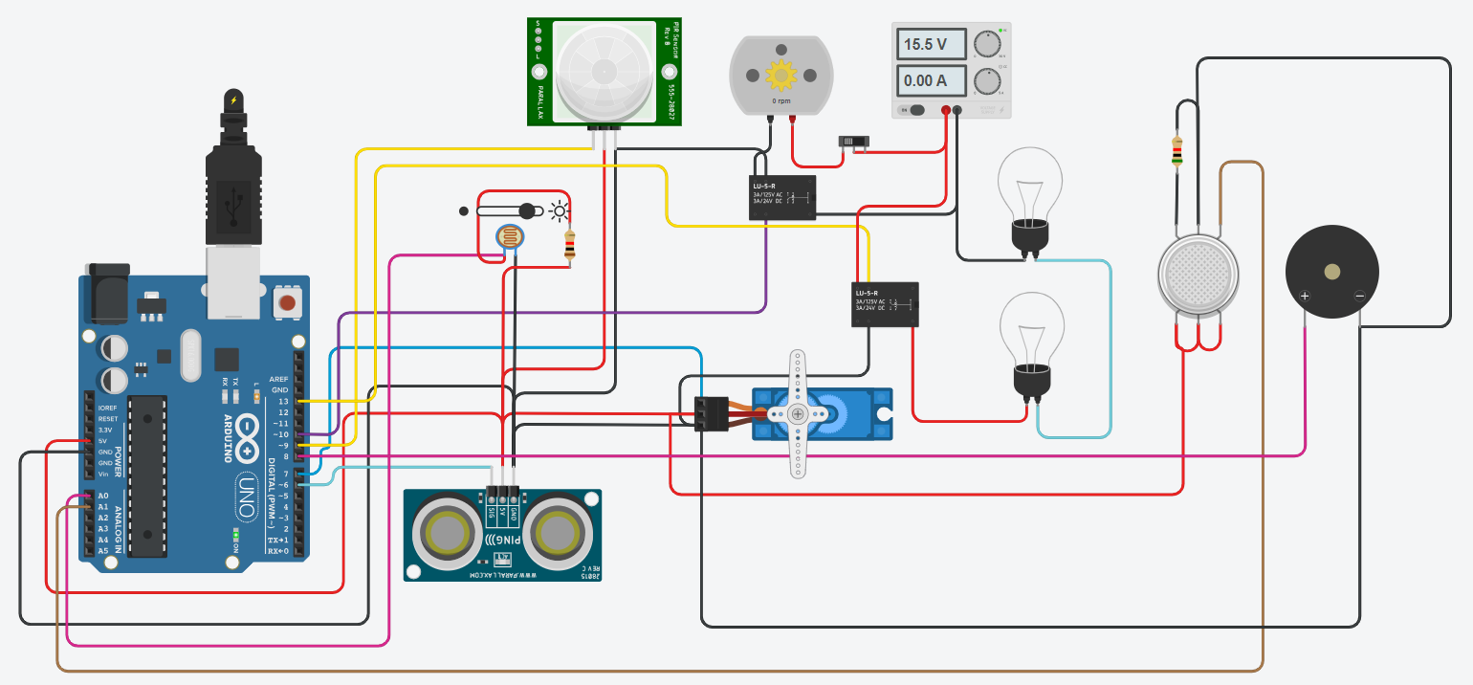

Bulbs turned off.

5.

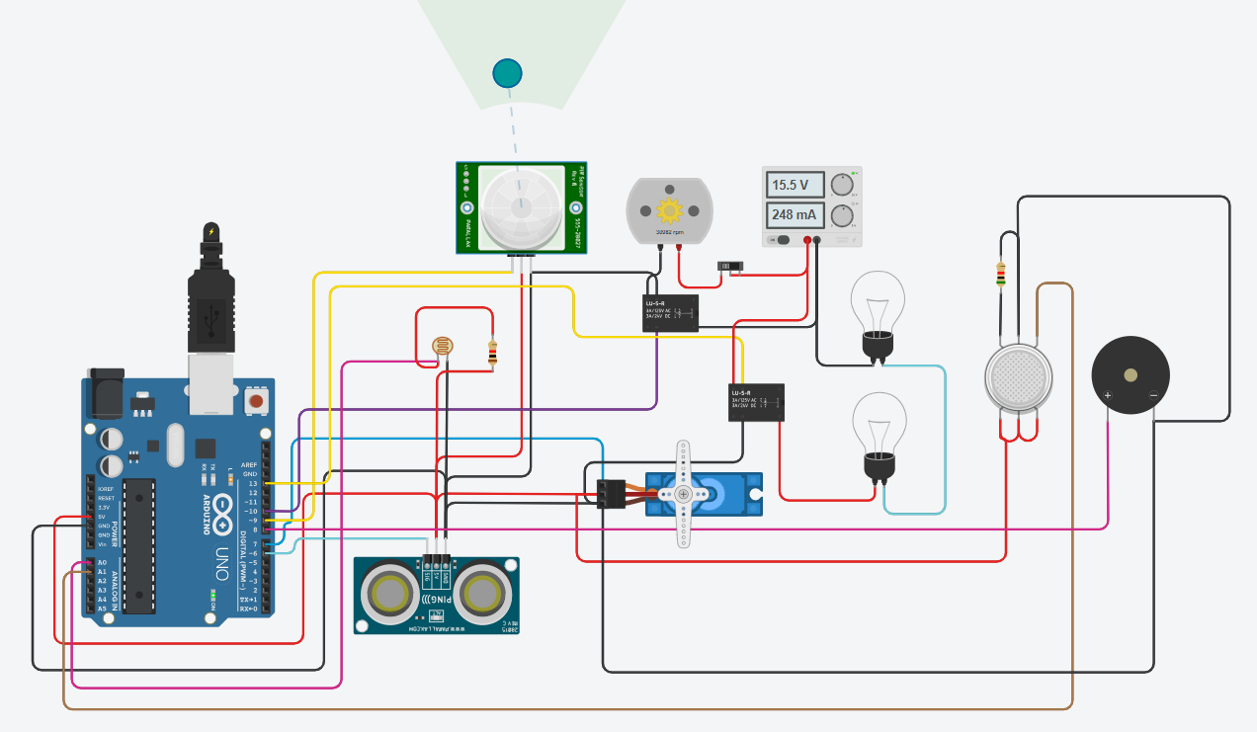

Automated fan turned on.

6.

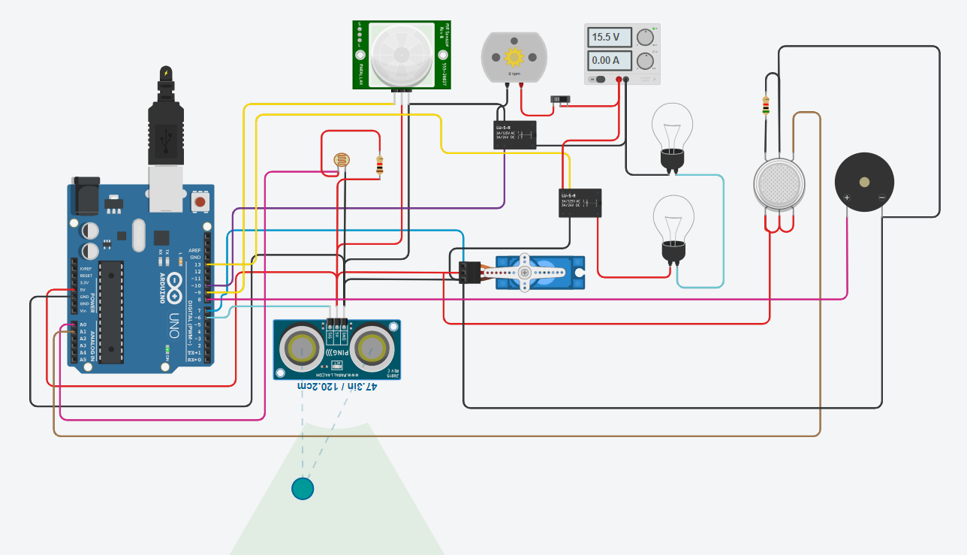

The door closed. (Micro servo rotated.)

Schematic View

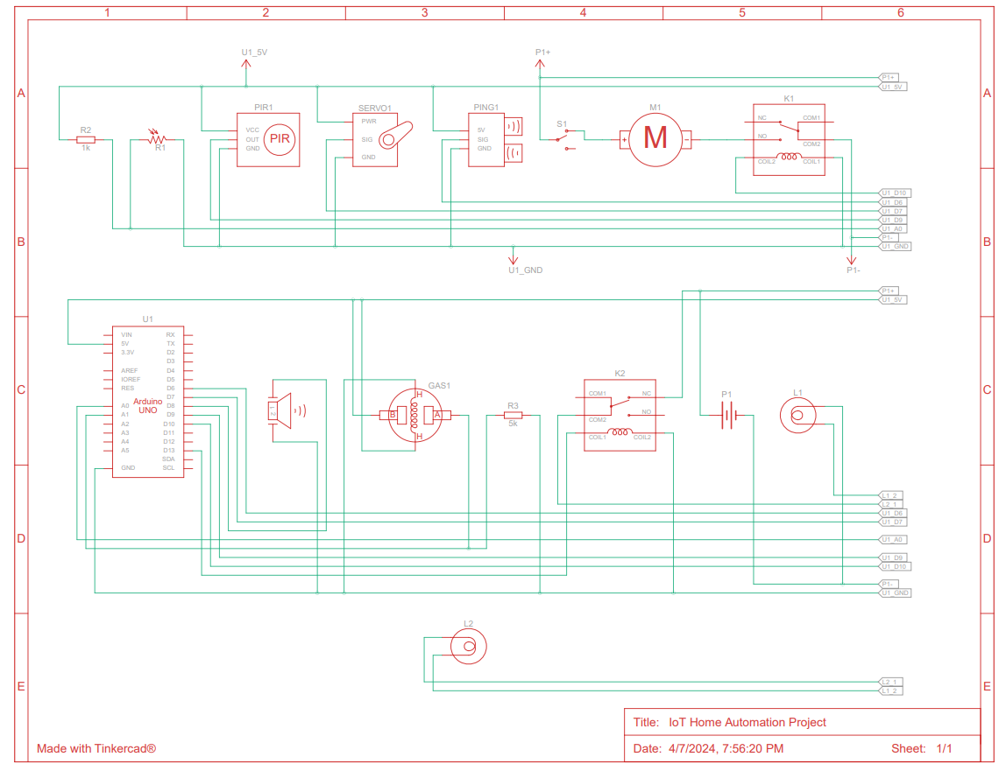

VII.

Arduino Code

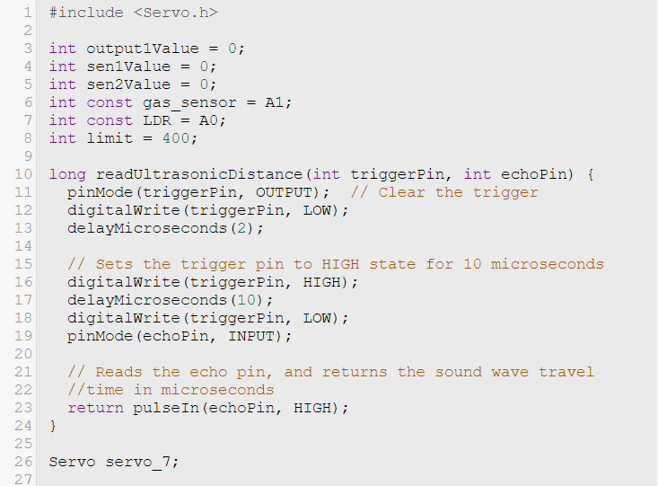

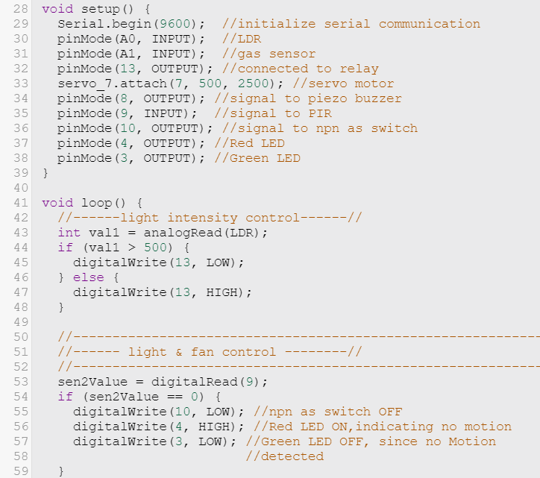

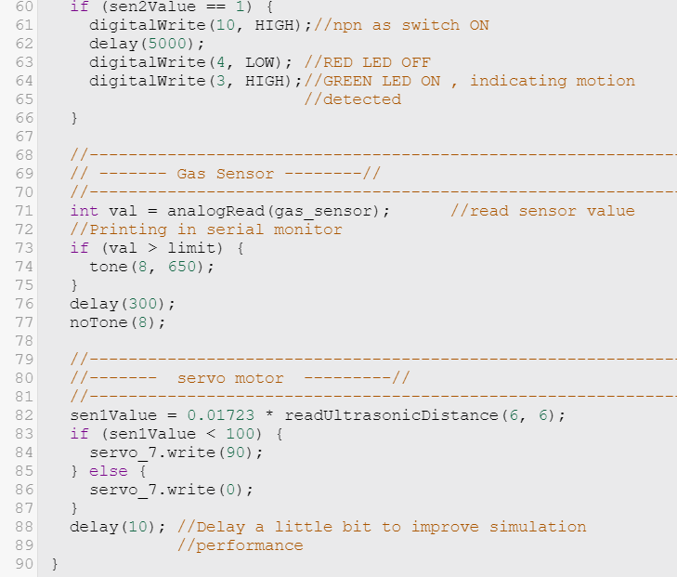

VIII.

Bibliography

1. Ideas to automate various components:

[geeksforgeeks.org/iot-home-automation/](https://www.geeksforgeeks.org/iot-home-automation/)

1. YouTube reference for TinkerCad:

[Home Automation Version 2](https://www.youtube.com/watch?v=0i7gKcAliiE)

1. My TinkerCad project:

[IoT Home Automation System](https://www.tinkercad.com/things/6gzM92vrxMS-iot-home-automation-project?sharecode=6EWkv71ADRonwgJKpBnHGA7w2SlH5c6i2uQv6Fkd_34)